XPS spectra
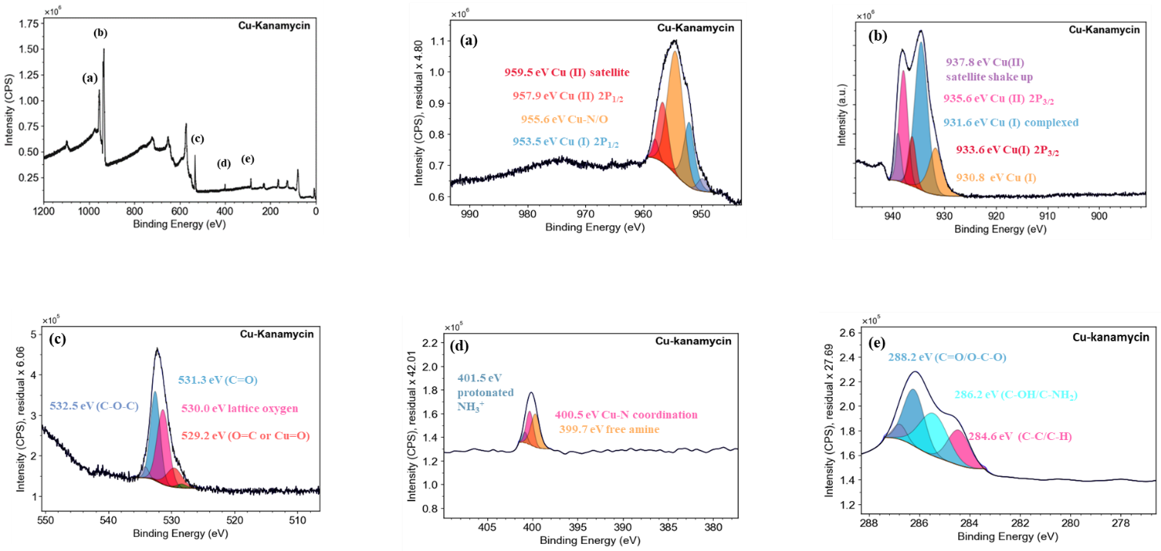
Figure 1 XPS spectra of Cu–Kanamycin showing Cu–N/O coordination (Cu 2p₃/₂), O 1s, N 1s, and C 1s core-level regions confirming successful metal–ligand complexation.
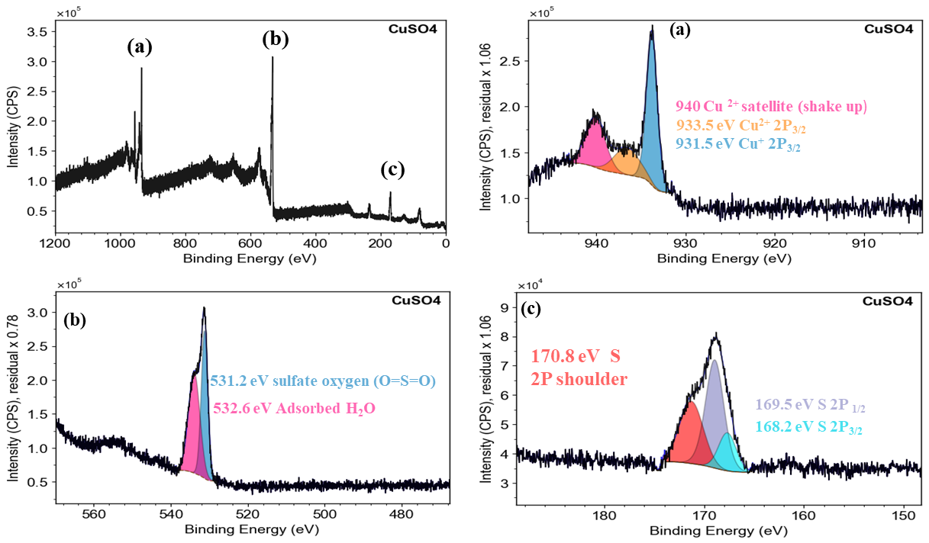
Figure 2 XPS spectra of CuSO₄ confirming the presence of Cu⁺/Cu²⁺ (Cu 2p₃/₂), sulfate oxygen (O 1s), and sulfate sulfur species (S 2p).
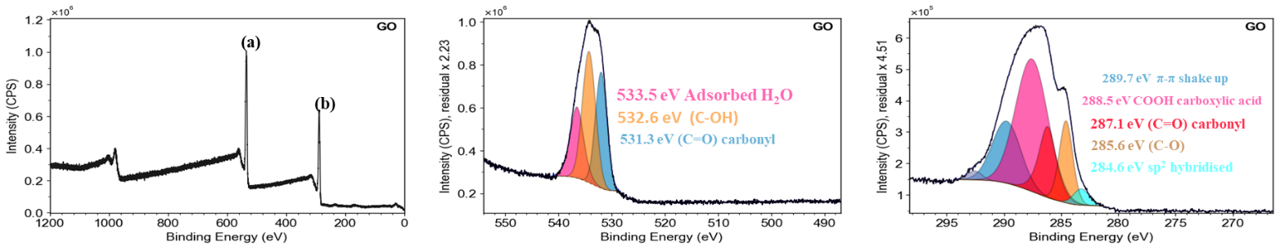
Figure 3 XPS spectra of graphene oxide (GO) showing oxygen functionalities in O 1s (C=O, C–OH, H₂O) and carbon environments in C 1s (C–C, C–O, COOH, π–π).
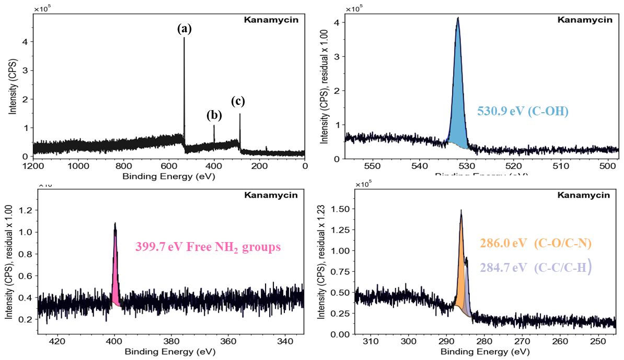
Figure 4 XPS spectra of kanamycin showing characteristic peaks for C–OH (O 1s, 530.9 eV), free NH₂ groups (N 1s, 399.7 eV), and C–C/C–H and C–O/C–N functionalities (C 1s, 284.7 and 286.0 eV), confirming its oxygenated and aminated structure.
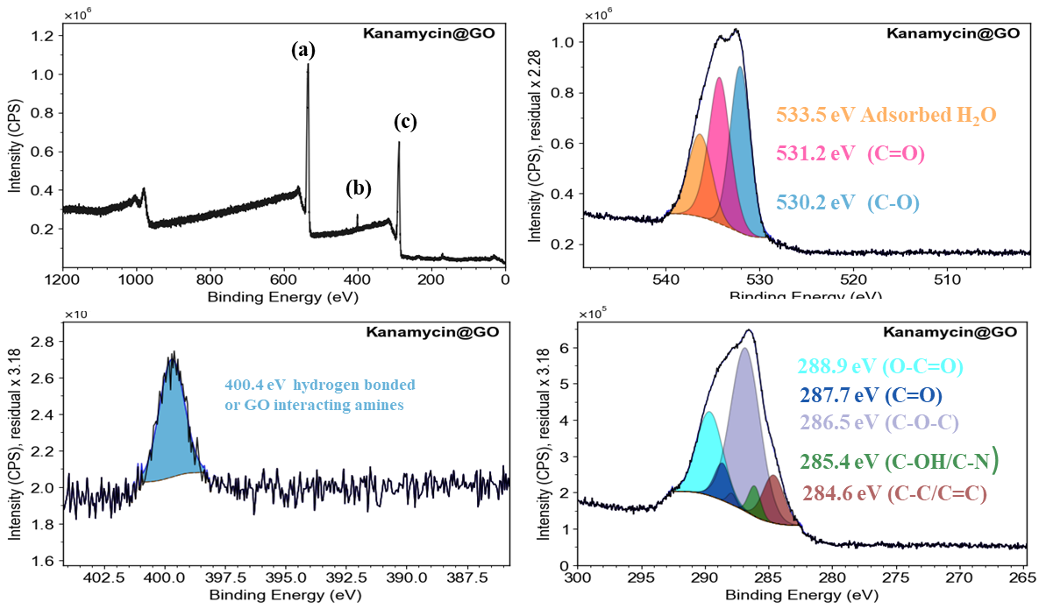
Figure 5 XPS spectra of Kanamycin@GO confirming amine–GO interaction (N 1s), oxygenated functionalities (O 1s), and diverse carbon states (C 1s) indicating successful conjugation.

